Question 251 ( Single Topic )

Which technology prevents client devices from arbitrarily connecting to the network without state remediation?

* **A.**802.11n
* **B.**802.1x
* **C.**MAC Authentication Bypass
* **D.**IP Source Guard

Answer : **B**

Question 252 ( Single Topic )

Which protocol does an access point use to draw power from a connected switch?

* **A.**Internet Group Management Protocol
* **B.**Cisco Discovery Protocol
* **C.**Adaptive Wireless Path Protocol
* **D.**Neighbor Discovery Protocol

Answer : **B**

Question 253 ( Single Topic )

An administrator must secure the WLC from receiving spoofed association requests. Which steps must be taken to configure the WLC to restrict the requests and force the user to wait 10 ms to retry an association request?

* **A.**Enable MAC filtering and set the SA Query timeout to 10.
* **B.**Enable 802.1x Layer 2 security and set the Comeback timer to 10.
* **C.**Enable Security Association Teardown Protection and set the SA Query timeout to 10.
* **D.**Enable the Protected Management Frame service and set the Comeback timer to 10.

Answer : **C**

Refer to the exhibit. Only four switches are participating in the VLAN spanning-tree process.  
  
Branch-1: priority 614440 -  
  
Branch-2: priority 39391170 -  
  
Branch-3: priority 0 -  
  
Branch-4: root primary -  
Which switch becomes the permanent root bridge for VLAN 5?

* **A.**Branch-1
* **B.**Branch-2
* **C.**Branch-3
* **D.**Branch-4

Answer : **C**

Question 255 ( Single Topic )

An engineer must configure traffic for a VLAN that is untagged by the switch as it crosses a trunk link. Which command should be used?

* **A.**switchport trunk encapsulation dot1q
* **B.**switchport trunk allowed vlan 10
* **C.**switchport mode trunk
* **D.**switchport trunk native vlan 10

Answer : **D**

Question 256 ( Single Topic )

What are two benefits of using the PortFast feature? (Choose two.)

* **A.**Enabled interfaces are automatically placed in listening state.
* **B.**Enabled interfaces wait 50 seconds before they move to the forwarding state.
* **C.**Enabled interfaces never generate topology change notifications.
* **D.**Enabled interfaces come up and move to the forwarding state immediately.
* **E.**Enabled interfaces that move to the learning state generate switch topology change notifications.

Answer : **AD**

Question 257 ( Single Topic )

What is the benefit of configuring PortFast on an interface?

* **A.**The frames entering the interface are marked with the higher priority and then processed faster by a switch.
* **B.**After the cable is connected, the interface is available faster to send and receive user data.
* **C.**Real-time voice and video frames entering the interface are processed faster.
* **D.**After the cable is connected, the interface uses the fastest speed setting available for that cable type.

Answer : **B**

##### Question 258 ( Single Topic )

DRAG DROP -  
Drag and drop the functions of AAA supporting protocols from the left onto the protocols on the right.  
Select and Place:

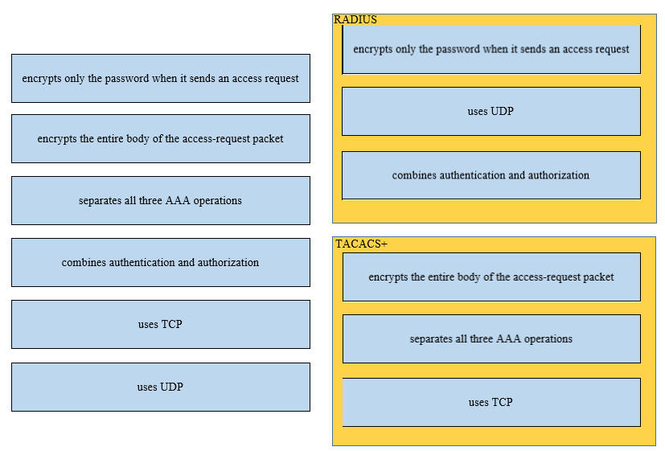

Question 259 ( Single Topic )

Why does a switch flood a frame to all ports?

* **A.**The frame has zero destination MAC addresses.
* **B.**The destination MAC address of the frame is unknown.
* **C.**The source MAC address of the frame is unknown
* **D.**The source and destination MAC addresses of the frame are the same.

Answer : **B**

Question 260 ( Single Topic )

An engineer configures interface Gi1/0 on the company PE router to connect to an ISP. Neighbor discovery is disabled.  
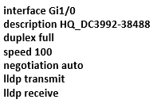  
Which action is necessary to complete the configuration if the ISP uses third-party network devices?

* **A.**Disable autonegotiation.
* **B.**Enable LLDP globally.
* **C.**Enable LLDP-MED on the ISP device.
* **D.**Disable Cisco Discovery Protocol on the interface.

Answer : **B**

##### Question 261 ( Single Topic )

DRAG DROP -  
Drag and drop the Rapid PVST+ forwarding state actions from the left to the right. Not all actions are used.  
Select and Place

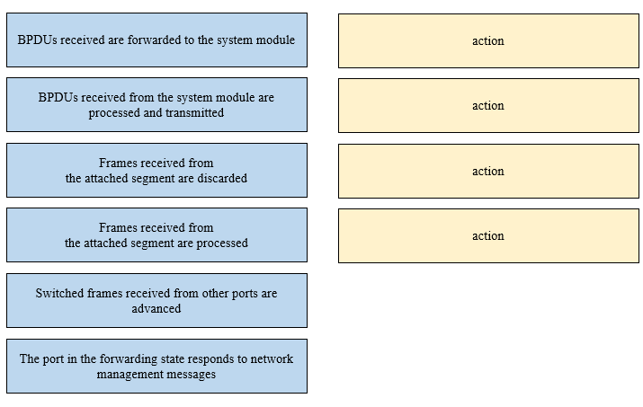

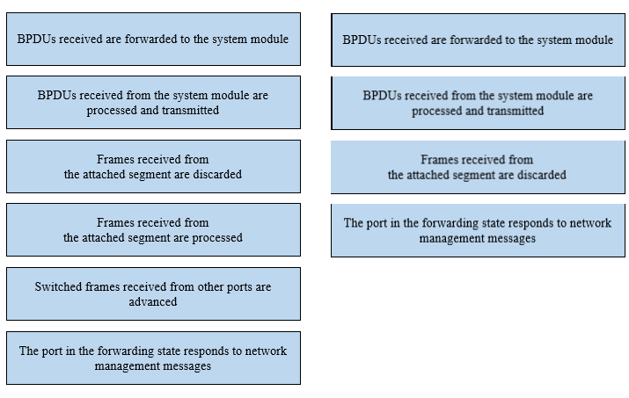

Question 262 ( Single Topic )

Which access point mode relies on a centralized controller for management, roaming, and SSID configuration?

* **A.**lightweight mode
* **B.**autonomous mode
* **C.**bridge mode
* **D.**repeater mode

Answer : **A**

 Next Question

Question 264 ( Single Topic )

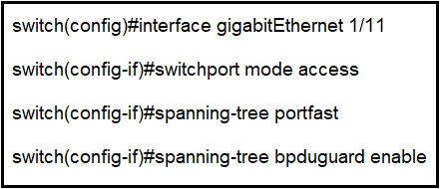  
Refer to the exhibit. What is the result if Gig1/11 receives an STP BPDU?

* **A.**The port transitions to STP blocking.
* **B.**The port immediately transitions to STP forwarding.
* **C.**The port goes into error-disable state.
* **D.**The port transitions to the root port.

Answer : **C**

Question 265 ( Single Topic )

Which access layer threat-mitigation technique provides security based on identity?

* **A.**Dynamic ARP Inspection
* **B.**DHCP snooping
* **C.**802.1x
* **D.**using a non-default native VLAN

Answer : **C**

Question 266 ( Single Topic )

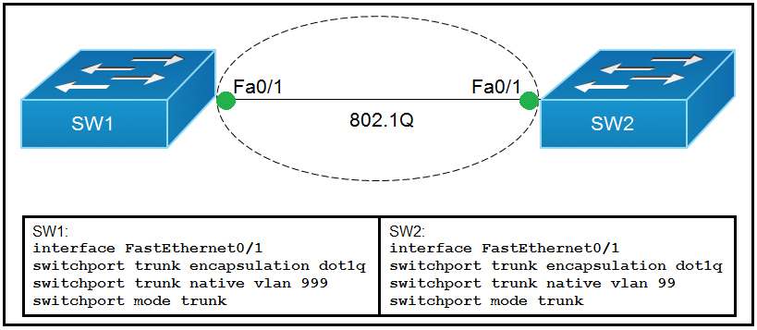  
Refer to the exhibit. Which action do the switches take on the trunk link?

* **A.**The trunk does not form, and the ports go into an err-disabled status.
* **B.**The trunk forms, but the mismatched native VLANs are merged into a single broadcast domain.
* **C.**The trunk forms, but VLAN 99 and VLAN 999 are in a shutdown state.
* **D.**The trunk does not form, but VLAN 99 and VLAN 999 are allowed to traverse the link.

Answer : **B**

Question 267 ( Single Topic )

A network engineer must configure two new subnets using the address block 10.70.128.0/19 to meet these requirements:  
✑ The first subnet must support 24 hosts.  
✑ The second subnet must support 472 hosts.  
✑ Both subnets must use the longest subnet mask possible from the address block.  
Which two configurations must be used to configure the new subnets and meet a requirement to use the first available address in each subnet for the router interfaces? (Choose two.)

* **A.**interface vlan 1148 ip address 10.70.148.1 255.255.254.0
* **B.**interface vlan 3002 ip address 10.70.147.17 255.255.255.224
* **C.**interface vlan 4722 ip address 10.70.133.17 255.255.255.192
* **D.**interface vlan 1234 ip address 10.70.159.1 255.255.254.0
* **E.**interface vlan 155 ip address 10.70.155.65 255.255.255.224

Answer : **DE**

Question 268 ( Single Topic )

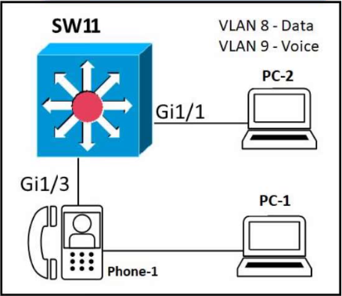  
Refer to the exhibit. An administrator must configure interfaces Gi1/1 and Gi1/3 on switch SW11. PC-1 and PC-2 must be placed in the Data VLAN, and Phone-1 must be placed in the Voice VLAN. Which configuration meets these requirements?

* **A.**interface gigabitethernet1/1 switchport mode access switchport access vlan 8 ! interface gigabitethernet1/3 switchport mode access switchport access vlan 8 switchport voice vlan 9
* **B.**interface gigabitethernet1/1 switchport mode access switchport access vlan 8 ! interface gigabitethernet1/3 switchport mode trunk switchport trunk vlan 8 switchport voice vlan 9
* **C.**interface gigabitethernet1/1 switchport mode access switchport access vlan 9 ! interface gigabitethernet1/3 switchport mode trunk switchport trunk vlan 8 switchport trunk vlan 9
* **D.**interface gigabitethernet1/1 switchport mode access switchport access vlan 8 ! interface gigabitethernet1/3 switchport mode access switchport voice vlan 8 switchport access vlan 9

Answer : **A**

Question 270 ( Single Topic )

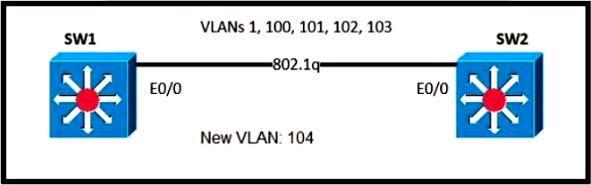  
Refer to the exhibit. An engineer is asked to insert the new VLAN into the existing trunk without modifying anything previously configured. Which command accomplishes this task?

* **A.**switchport trunk allowed vlan 100-104
* **B.**switchport trunk allowed vlan 104
* **C.**switchport trunk allowed vlan all
* **D.**switchport trunk allowed vlan add 104

Answer : **D**

Question 271 ( Single Topic )

Aside from discarding, which two states does the switch port transition through while using RSTP (802.1w)? (Choose two.)

* **A.**blocking
* **B.**speaking
* **C.**listening
* **D.**learning
* **E.**forwarding

Answer : **DE**

##### Question 272 ( Single Topic )

DRAG DROP -  
Drag and drop the facts about wireless architectures from the left onto the types of access point on the right. Not all options are used.  
Select and Place:

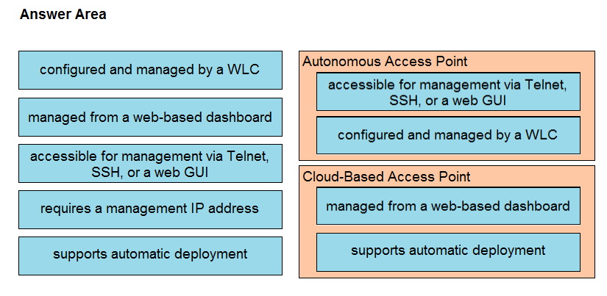

Question 273 ( Single Topic )

Which interface mode must be configured to connect the lightweight APs in a centralized architecture?

* **A.**WLAN dynamic
* **B.**trunk
* **C.**access
* **D.**management

Answer : **C**